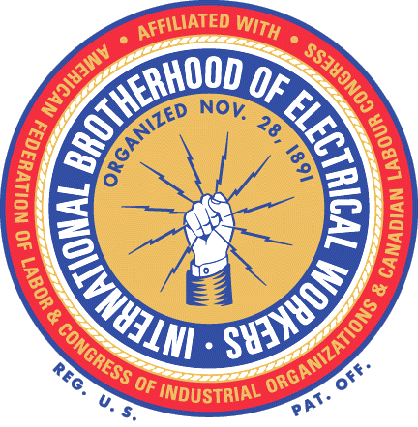

®

That’s right! It will not cost any employee even One Red Cent to find out
what the IBEW can do and will do for us.

There will be NO DUES until the IBEW negotiates a contract acceptable to us by secret ballot vote. This means as soon as we win our NLRB election, our negotiations will start, but we will pay nothing until the IBEW delivers the contract. Nor will there be any initiation fee for any current employee. All we need to do is sign a membership application card during the sixty (60) days open charter period following the ratification of our IBEW contract.

The IBEW is the largest union of electrical workers in the country and has been negotiating contracts since long before any of us were born. The IBEW is confident – so confident that it will not cost us even One Red Cent to find out for ourselves. The IBEW says, “The proof is in the contract.”

WHO WILL PAY FOR OUR NEGOTIATIONS? IBEW WILL!
WHO WILL TRAIN OUR OFFICERS AND STEWARDS? IBEW WILL!
WHO WILL PAY FOR OUR CONTRACT RESEARCH? IBEW WILL!
WHO WILL FURNISH SKILLED NEGOTIATORS? IBEW WILL!

And only after the IBEW delivers the contract we want – acceptable by our own vote –
will we be asked to start paying dues.

Who Will Be Present at the Negotiations?

We will have our own negotiating committee to go with the IBEW negotiators.
It’s the IBEW way.

We Will Be Present – No Secrets

ONE COMPANY – ONE UNION – VOTE IBEW

www.ibew.org

Form MD3013

